Capstone Project Weekly Progress Report

|  |  |
| --- | --- |
| Semester | Fall 2021 |
| Course Code | AML 3406 |
| Section | Section 2 |
| Project Title | Restaurant Recommending Chatbot |
| Group Name | Group 3 |
| Student names/Student IDs | Vignesh Kumar Murugananthan C0793760 |
| Reporting Week | Week 5 – 10/09/2021 |
| Faculty Supervisor | Vahid Hadavi |

# **Tasks Outlined in Previous Weekly Progress Report**

* Created GIT Repository
* Downloaded the latest data from Yelp in Json format
* Loaded them in local repository
* Installed MongoDB in cloud service
* Imported the dataset into MongoDB
* Structured the data

# **Progress Made in Reporting Week**

* Analyzed Business data and Review data
* Explored the data to find various insights in them
* Grouped data based on the restaurant category and visualized them in order to understand how the data is represented.

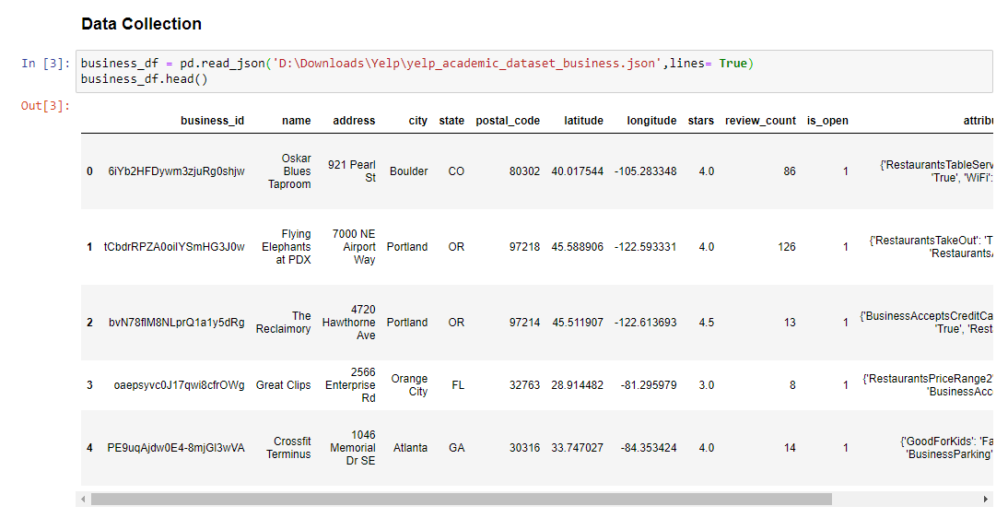

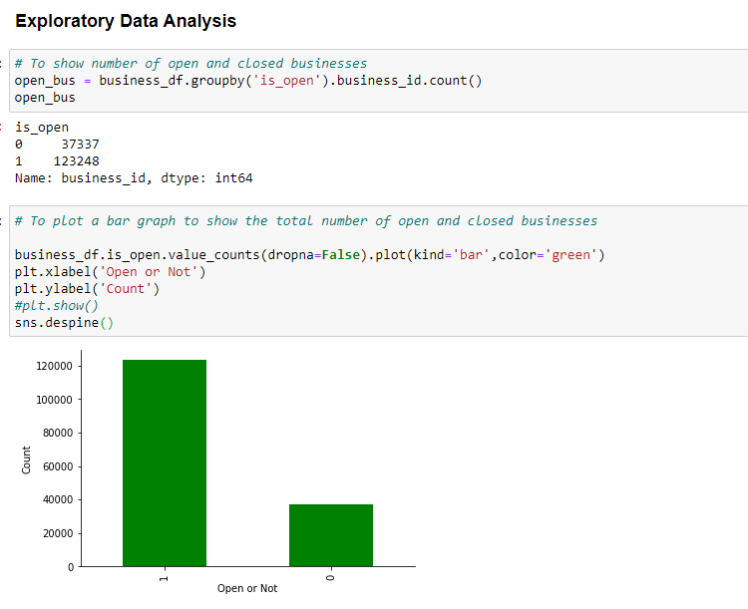

# **Difficulties Encountered in Reporting Week**

* We faced few issues with the performance, so currently in choosing the best model which makes the model to perform better with more data.

# **Tasks to Be Completed in Next Week**

* NLP Concepts - Finding the best restaurants for particular cuisines
* Modelling
* Model Evaluation
* Cosine Similarity
* Chat bot Building

Overall Project Plan:

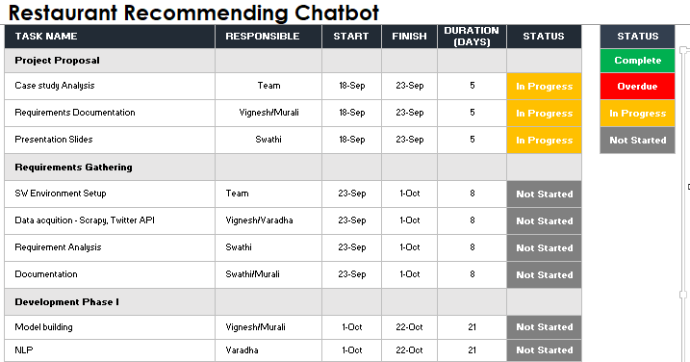

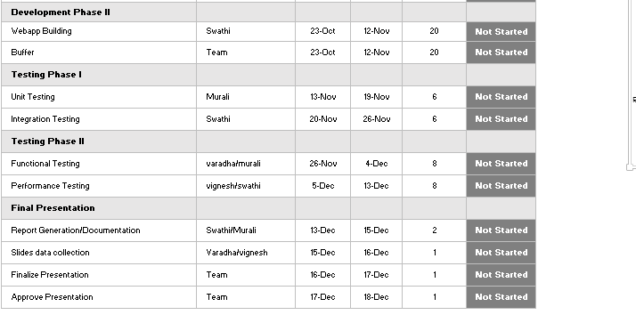

Individual Project plan:

Case study analysis

S/W environment setup

Development phase 1 – NLP

Development Phase 2 – Webapp Building

Testing Phase 2 – UNIT and Integration testing

HIGLIGHTED BELOW ARE MY RESPONSIBILITIES

